Team Foundation Server 2008 Management Pack for System Center Operations Manager 2007 User Guide

Release 1, 11/15/2008

This user guide refers to Team Foundation Server 2008 Management Pack for System Center Operations Manager 2007 release 1 published in November 2008. For sake of brevity, we are going to refer to this product as Team Foundation Server MP in this document.

This document assumes that Team Foundation Server MP and all of its prerequisites have been correctly installed by following the instructions in the “Installing Management Pack for Team Foundation Server 2008 for System Center Operations Manager 2007” document.

# Service Model

The Team Foundation Server MP Service Model consists of the classes representing various objects that are representative of Team Foundation Server. System Center Operations Manager 2007 (OpsMgr) makes use of these classes to discover Team Foundation Servers in your managed environment and populate them with the appropriate property values and also detect their health states and actively monitor them.

## CLASSES

The Service Model consists of the following list of classes:

1. Team Foundation Server application tier
2. Team Foundation Server Web Services
   1. Team Foundation Server Build Web Service
   2. Team Foundation Server Version Control Web Service
   3. Team Foundation Server WorkItem Tracking Web Service
   4. Team Foundation Server Warehouse Web Service
   5. Team Foundation Server SERVICE Web Service
3. Team Foundation Server Build Server
4. Team Foundation Server Database Instance (SQL)
5. Team Foundation Server Databases
6. Team Foundation Server Reporting Services (SSRS)
7. Team Foundation Server Analysis Services (SSAS)
8. Team Foundation Server WSS Portal
9. Team Foundation Server Proxy Server

## RELATIONSHIPS

Containment relationships are also enabled between the classes in which the application tier contains the Web Services and the Core Version Control and WorkItem tracking Databases.

# Discovery Process

Once the installation has been successfully performed and Team Foundation Server MP is loaded, the discovery process can start. At the end of this process which usually takes about 2-5 minutes, various Team Foundation Server objects are created and their properties are set with discovered values. The screen shots below capture Team Foundation Server objects that have been discovered. This might vary for different Team Foundation Servers based on the installed configuration. Along with the objects, the relationships between these objects also get established.

## Team Foundation Server Application Tier Objects

The following picture shows that two application tier objects have been discovered which means that there are two Team Foundation Servers on this set of managed servers. This again will vary based on the specific local environment where Team Foundation Server MP is used.

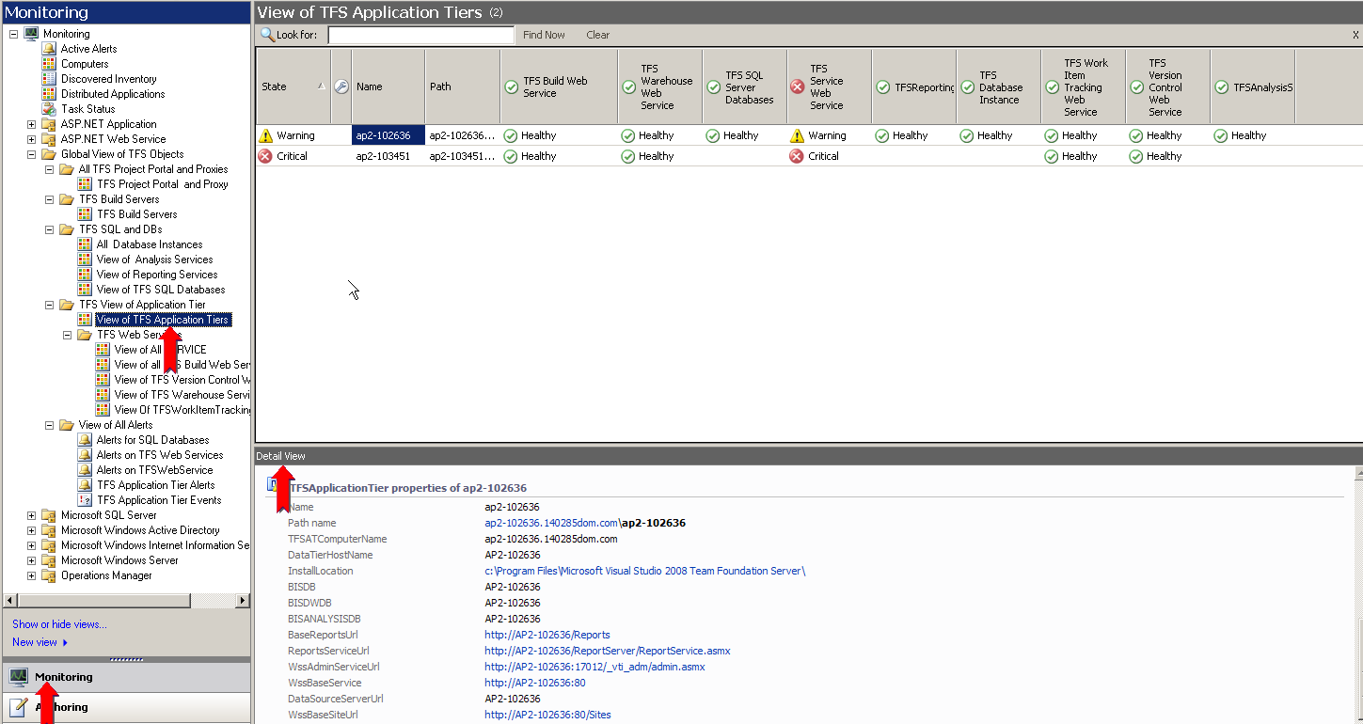

Figure: application tiers Discovered.

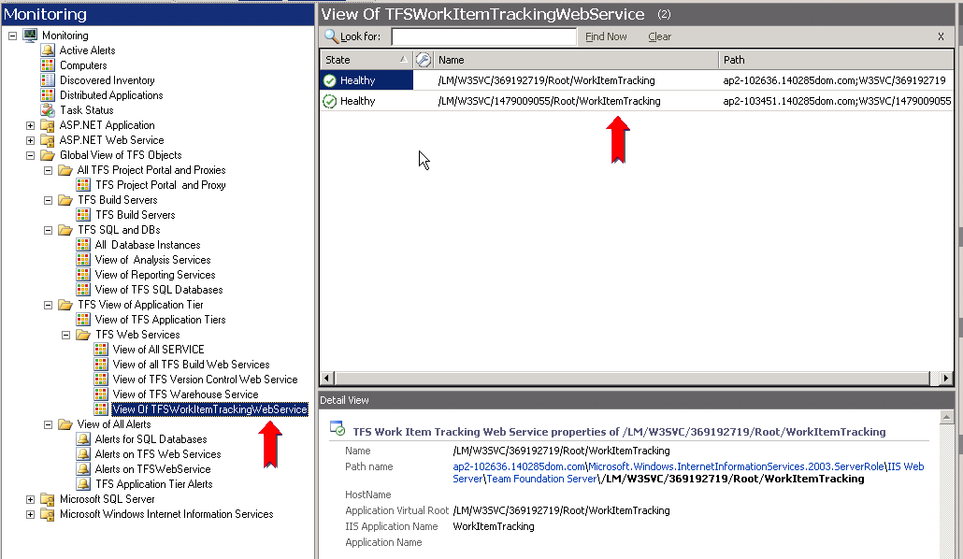

Figure: Workitem Tracking Web Services discovered

Similarly, other Team Foundation Server objects that have been detected can be navigated to in the left pane and browsed from the Operator Console.

# Health Model

Health Model is comprised of the dynamic view of the states of various Team Foundation Server objects. Note that the health states of the Team Foundation Server application tier, is a dependent function of the health of its sub-components. There is a dependency relationship in the health model as rollup of health states from the sub-components to the top level node happens.

To view the health model of any entity, right click on the object in the “Details View” in the middle pane and click Open->Health Explorer for that specific object. Or just click on the Health Explorer in the Actions Pane on the right. The health explorer can be launched for the top level object as well as the objects lower in the hierarchy.

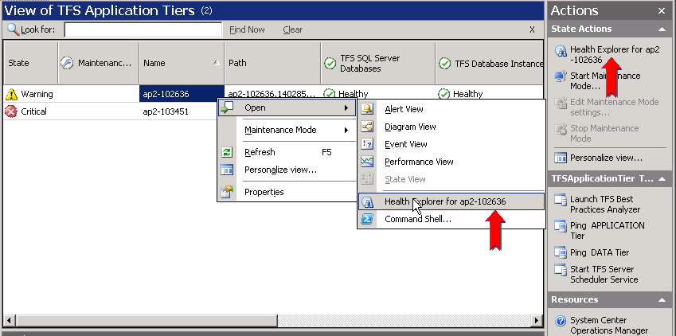

Figure: Launching the Health Explorer

Once the Health Explorer is launched, its window pops up showing the state of the object and the various monitors of that object arranged in a tree view as shown below.

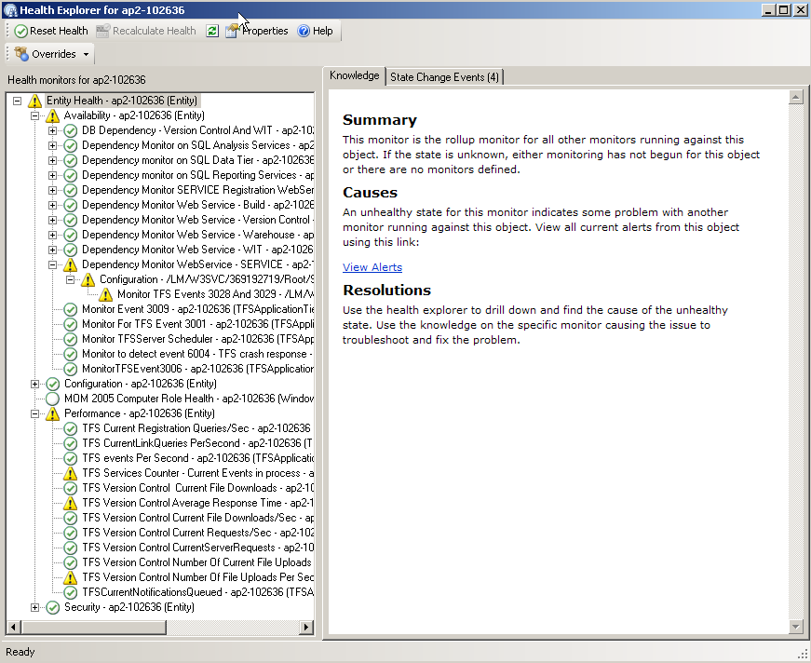

Figure: Health Explorer

The following is another view of the Health Explorer for an object showing a few unhealthy states (red). Additionally, the possible causes and resolutions are listed on the “Knowledge” article on the right.

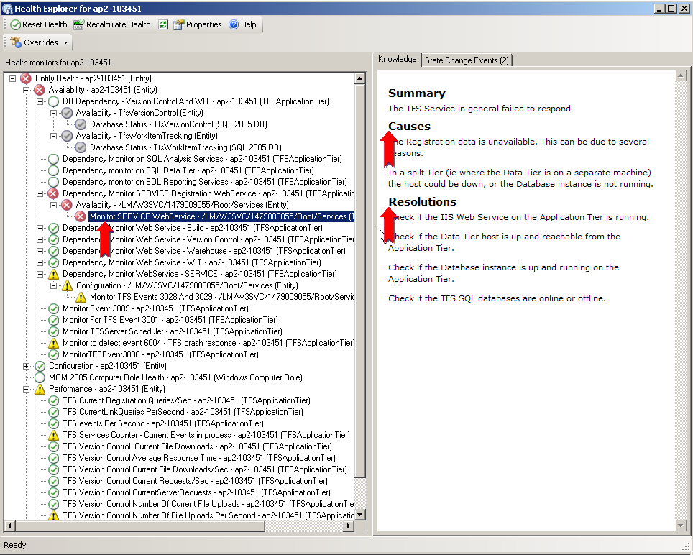

Figure: Another view of the Health Explorer showing a few availability monitors in unhealthy state

As mentioned, the health model is a reflection of the state of the object instance at that point in time and is constantly updated by the various monitors that run in the background. Incidentally, the health model also shows the containment relationships of the service model in the form of the ability to drill down into the contained objects health. In the above example, the containment relationship between the application tier (AT) and Team Foundation Server databases and the containment relationship between the AT and the various web services are expanded and shown.

# Monitors

As of this writing, there are a total of 59 Monitors and this number is expected to increase as the opportunities to add more meaningful monitors are observed during testing. Primarily the Monitors are comprised of WebService Monitors which query the various web services for proper response status. The majority of the monitors are made up of Team Foundation Server events and the threshold counters.

# Self Tuning – Establishing baselines

Please see <http://technet.microsoft.com/en-us/library/bb381480(TechNet.10).aspx> on the procedure.

# Diagram Views.

The relationship between the various objects in the Service Model for Team Foundation Server can also be viewed by using the Diagram View feature of the Operator Console.

The diagram view is accessed by right clicking the object in question and choosing the “Diagram View” menu option as shown below.

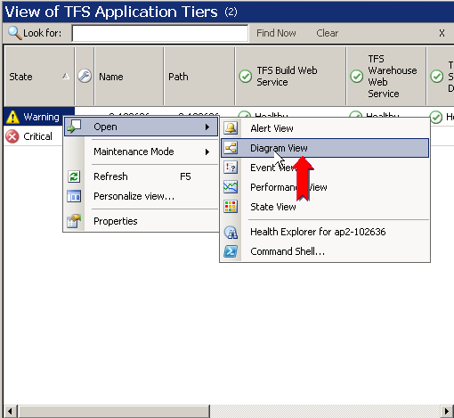

Figure: Opening the Diagram View

Once the basic view shows up, refresh the Diagram View pane and click on the + sign to drill down deeper if requuired. Sometimes the Diagram view surface is blank and may need to be refreshed.

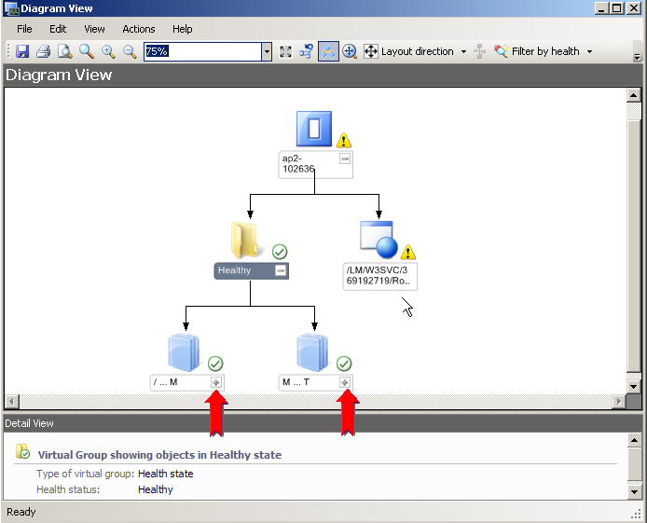

Figure: Diagram View with drill down



Figure: Diagram View after full drilled down

# Alert Views

The following Alert Views are defined in the Operator Console.

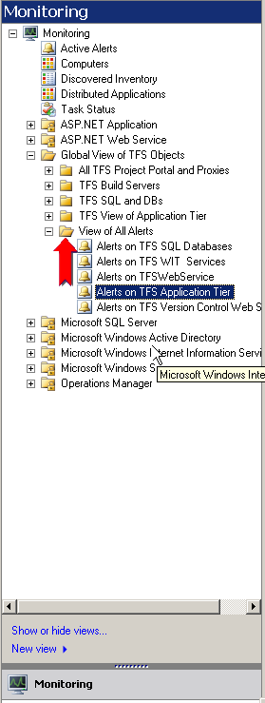

Figure: Alert View node on the Monitoring console.

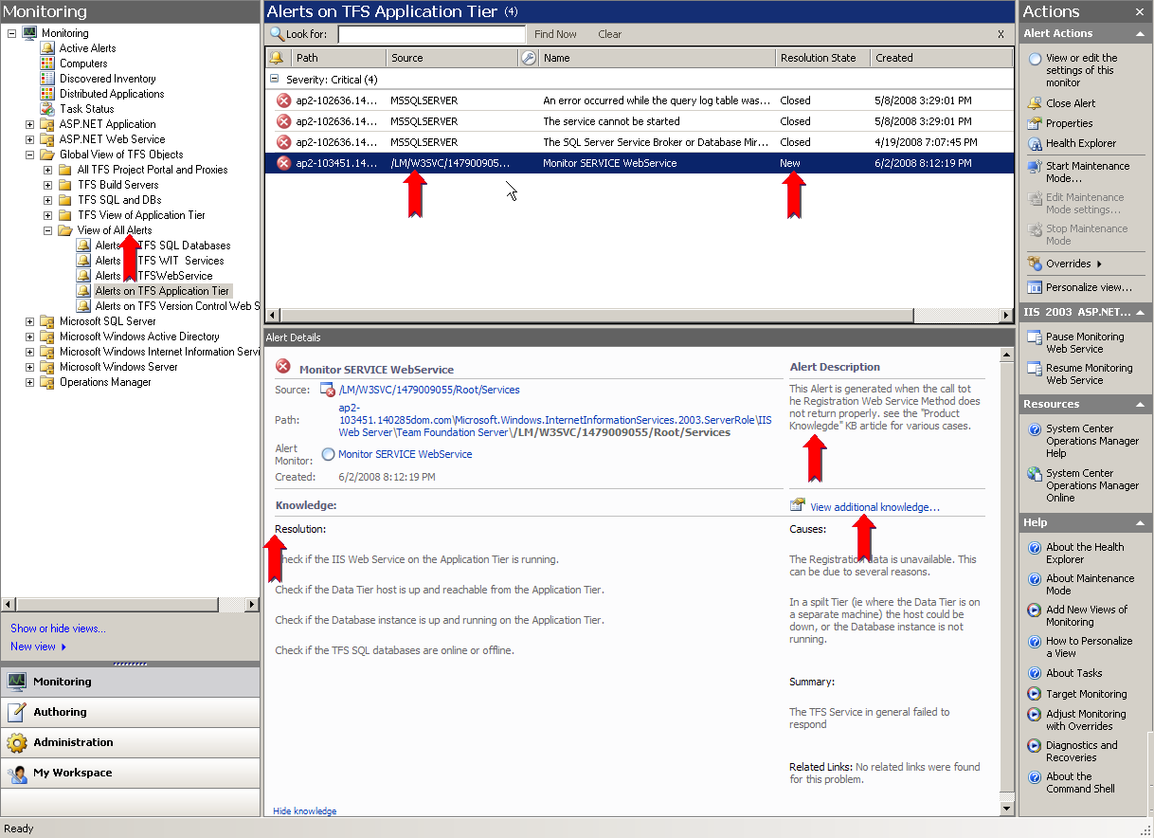

Figure: View of a few Alerts

# Rules

There are a total of 9 rules, and this number can also grow. Adding more rules increases the value of the MP. The rules manifest as Alerts in the Operator Console if they are fired after they detect unhealthy states.

# Tasks

There are two types of tasks. Console tasks which execute on the Operator Console host and Agent tasks which execute remotely on the host where the OpsMgr Agents are installed. In case of Team Foundation Server, these will be on the hosts where the application tier is detected. These tasks can be launched by double clicking.

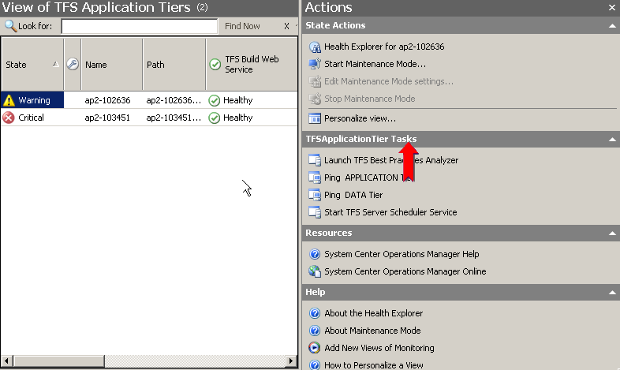

Figure: Launching Tasks

## Console Tasks

1. Ping application tier Machine: Ping the application tier machine and check if it is reachable.
2. Ping Data Tier Machine: Ping the Data Tier machine and check if it is reachable.

The following is the output window when the task “Ping Data Tier” is launched.

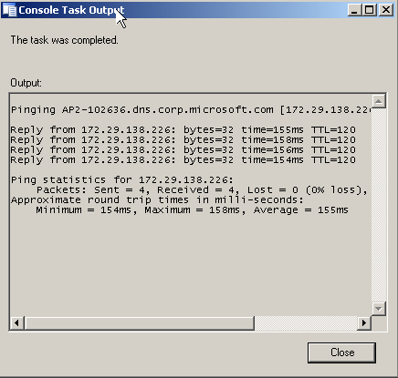

Figure: Output of Console Task “Ping Data Tier”

## Agent Tasks

1. Launch Best Practice Analyzer (BPA) for Team Foundation Server –

To launch BPA for Team Foundation Server, it has to be installed on the default locations on those machines where a Team Foundation Server application tier has been discovered. The following shows the “TFS BPA Launch” dialog box. Clicking on Run will produce an output file by BPA for Team Foundation Server in the C:\TEMP\TFSBPAOUTPUT folder on the Agent machine. To enable this feature, BPA for Team Foundation Server has to be installed in the default location and the output folder must exist.

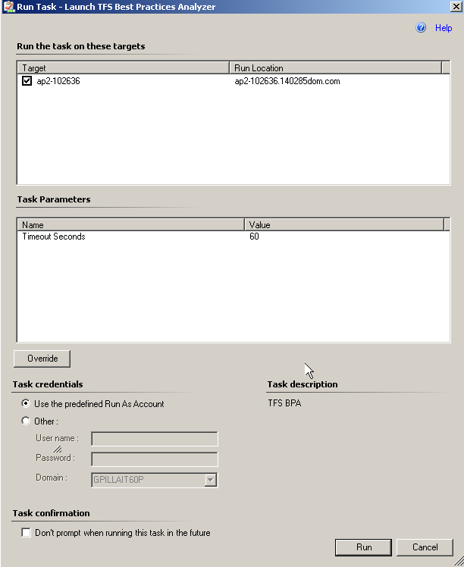

Figure: Dialog of Agent Task “Launch TFS Best Practices Analyzer”

1. Start Team Foundation Server Service Scheduler.
   1. If for some reason Team Foundation Server Service Scheduler process on the AT is down, this can be used to restart it.

# Diagnostics and Recoveries

There are a few diagnostic and recovery actions included. These are primarily for the “Team Foundation Server Service Scheduler” and “Team Foundation Server Build Server” services. If any of these services stop, the MP detects this situation and attempts a recovery by initiating a restart.

# Reports

The Team Foundation Server MP leverages the reporting infrastructure of Operations Manager 2007. The following standard reports are delivered with this release.

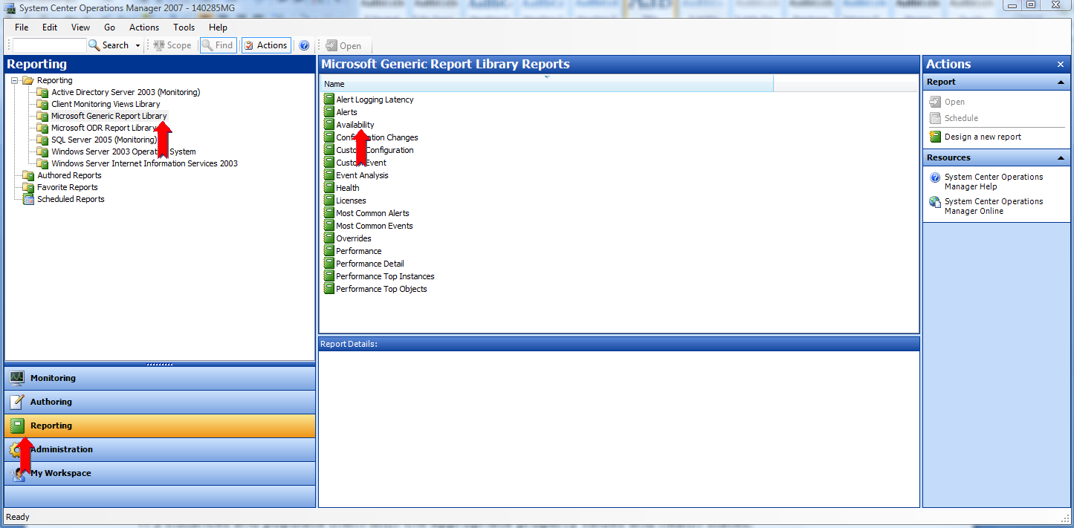

Figure: Operation Manager 2007 Standard Reports

A few sample reports are shown below.

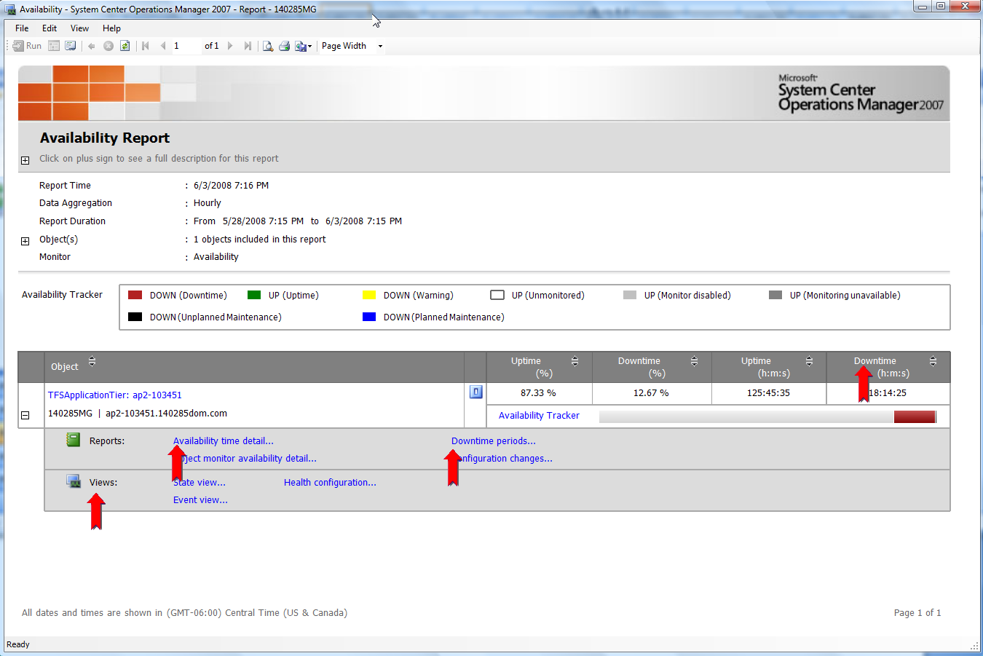

Figure: Availability of Team Foundation Server application tier

The availability report allows drill down detail of downtime. More actions are available by clicking on the actions + plus sign on the report.

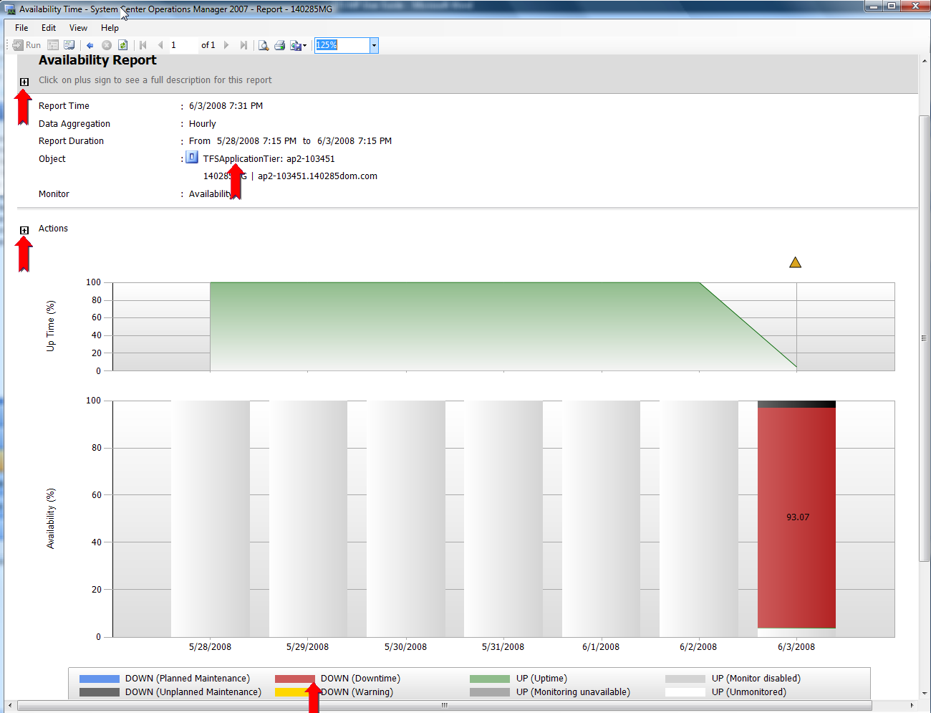

Figure: Drill down into availability time details

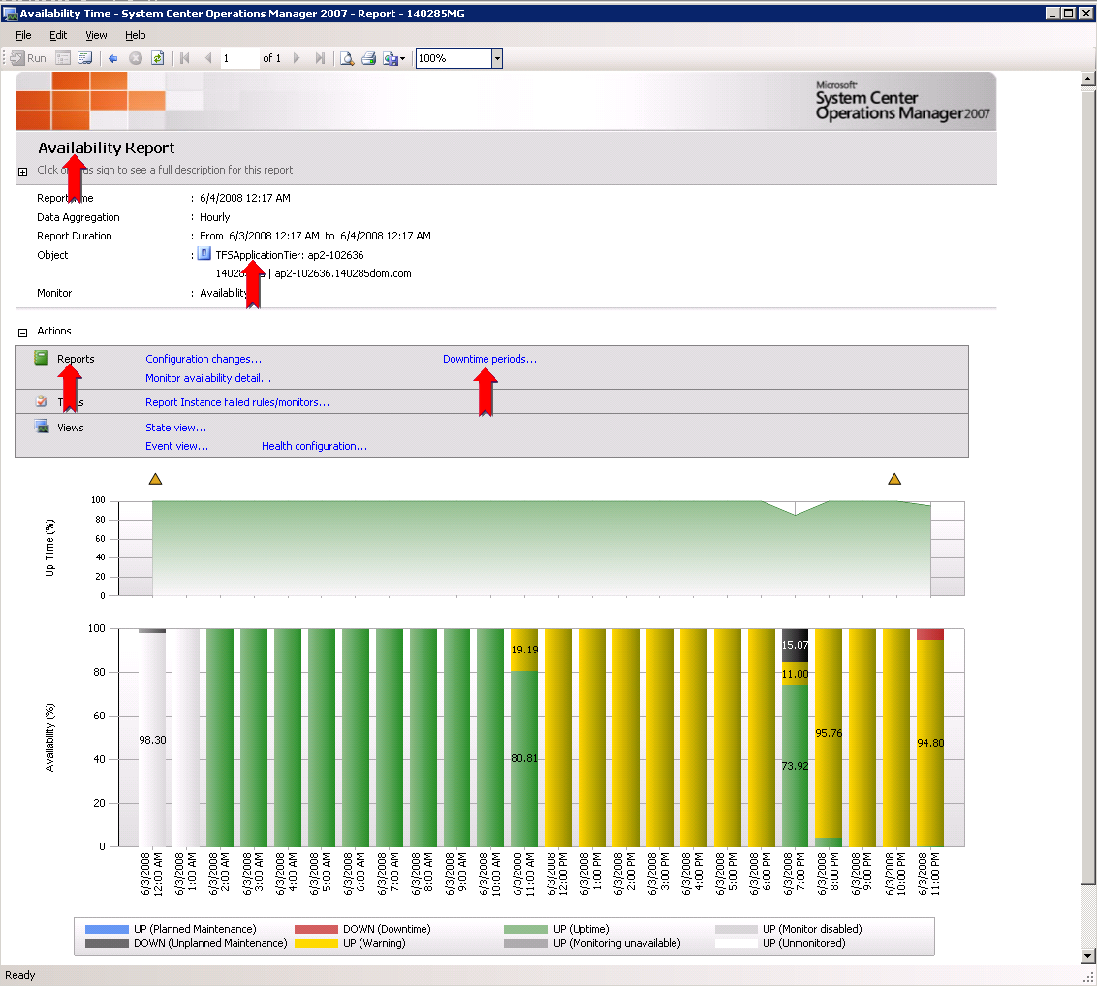

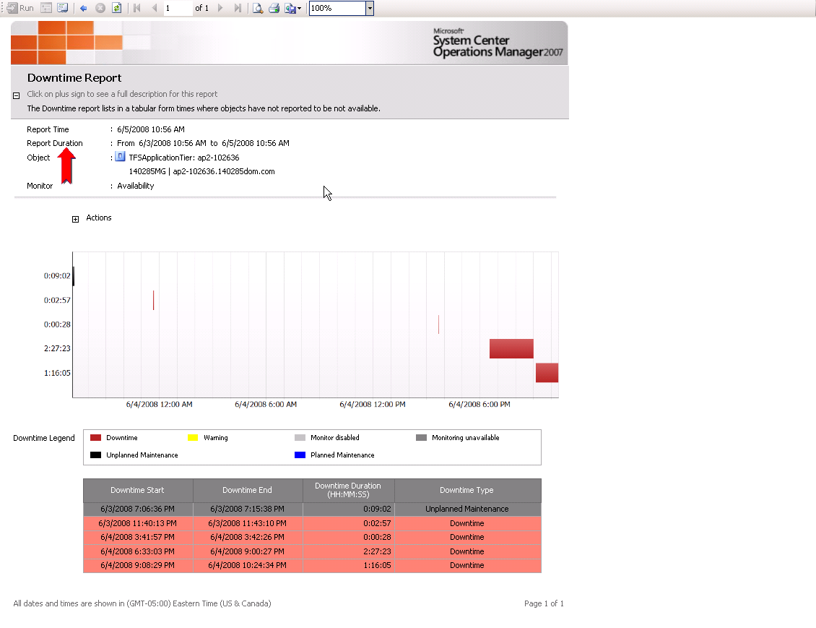

Figure: Downtime periods

The following is an example of an Alert Report

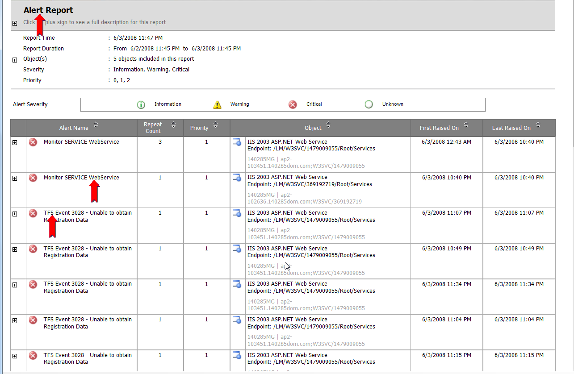

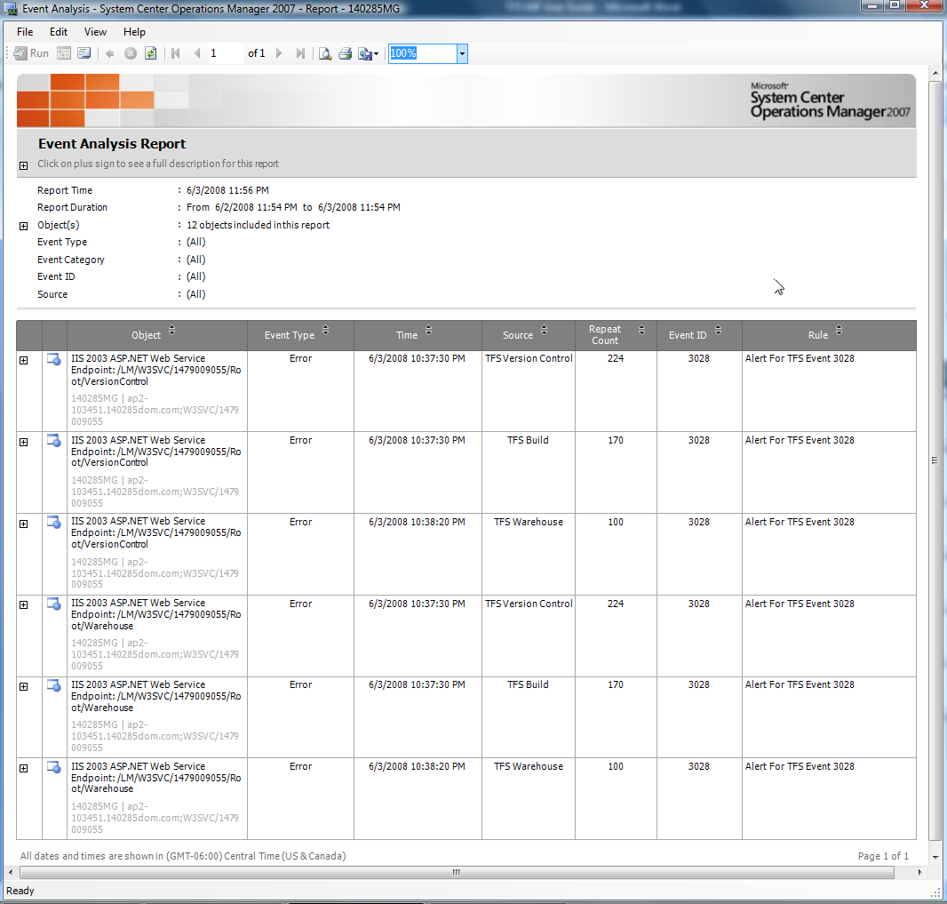

Health – Availability Report

